SQL Learning



Nithish Gowda

**Functions in SQL :**

**Aggregate function**

**String function**

**Date and Time Functions**

**Mathematical function**

**Conditional function**

**Window / Analytical function**

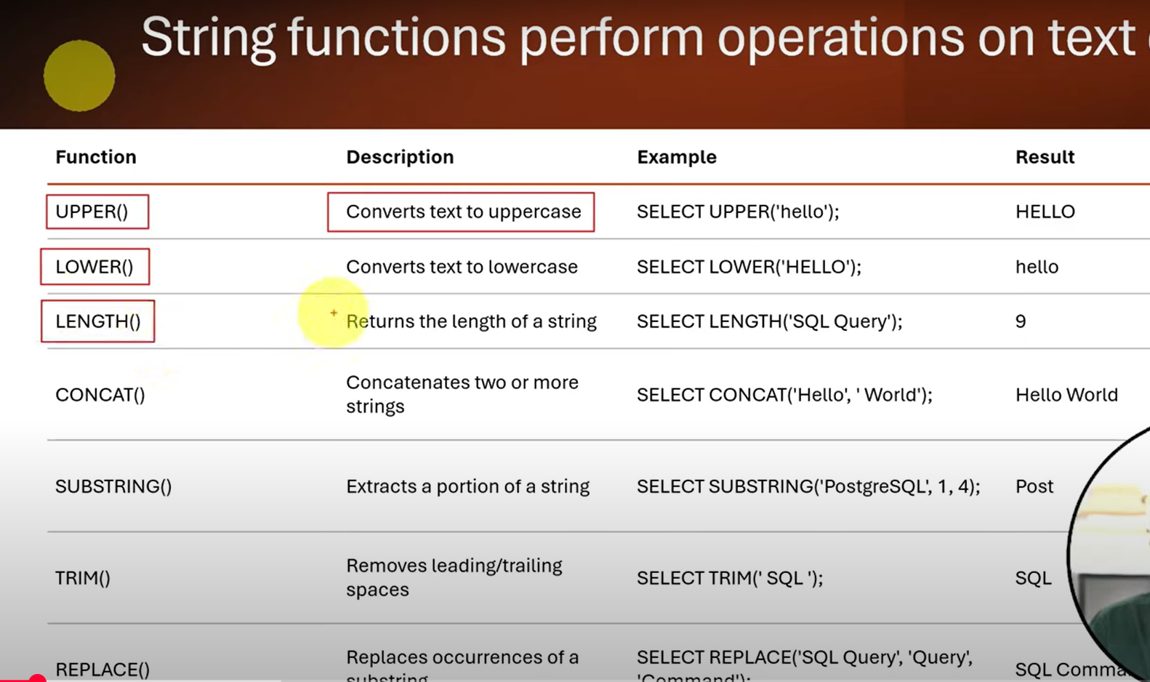

---get all category in upper case----

select upper(category) as category_upper

from products;

--concat function(product name and category)----

select concat(product_name,'-',category) as product_details

from products;

---substring - extarct first 5 char----

select substring(product_name,1,5) as short_name --1 starting, 5 until 5 char--to extract

from products;

---count length----

select product_name,length(product_name) as length

from products;

--remove leading and trailing spce from words---

select length(trim(' monitor ')) as trimmed_text;

select length(' monitor ') as trimmed_text;

---replace function - replace a word 'phone to device'----

select replace(product_name, 'phone', 'device') as update_name

from products;

--get first 3 character from category----

select left(category,3) as half_name

from products;

select right(category,5) as half_name

from products;